**Capstone Project – Phase 5 Report**

1. **Objective**

In this phase, we take the logic tables and create them we then insert sample data while enforcing integrity and constraints.

1. **Tables Created**

Among the tables i created include the Users table to store credentials and roles, the products table to store the items available in the store, the transactions table to record inventory stock movements, the suppliers and the categories among others.

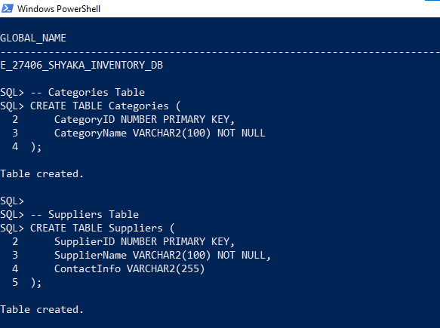

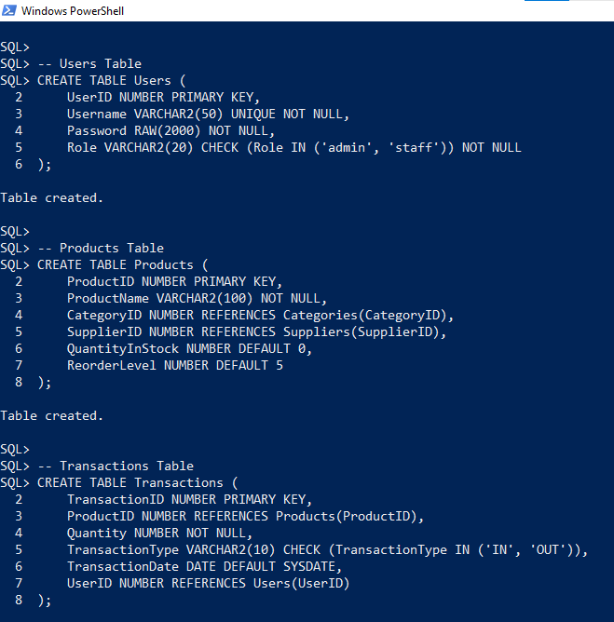

In Creating the above tables, i used and applied constraints such as the Primary Key the Foreign key the Not null key the check and the default key among others.

After that i inserted sample data as shown below;

